**The OSCQR Rubric**

*Note: The instrument in Google Form (where consent form is incorporated) can be viewed at this link:*

[*https://docs.google.com/forms/d/e/1FAIpQLSf60aoDhN1rytWNKg51nLqON288yg9UpYZvqf_lBwZZ7fy4Ew/viewform*](https://docs.google.com/forms/d/e/1FAIpQLSf60aoDhN1rytWNKg51nLqON288yg9UpYZvqf_lBwZZ7fy4Ew/viewform)

|  |  |  |  |  |
| --- | --- | --- | --- | --- |
| **Criteria** | **Rating** | | | |
| **Not Acceptable**  **(1)** | **Acceptable**  **(2)** | **Very Acceptable**  **(3)** | **Highly Acceptable (4)** |
| 1. **Overview & Information** |  |  |  |  |
| 1. **The course includes Welcome and Getting Started Content** |  |  |  |  |
| 1. **An orientation or overview is provided for the course overall, as well as in each module. Learners know how to navigate and what tasks are due.** |  |  |  |  |
| 1. **Course includes a Course Information area that deconstructs the syllabus for learners in a clear and navigable way.** |  |  |  |  |
| 1. **A printable syllabus is available to learners (PDF, HTML).** |  |  |  |  |
| 1. **Course includes links to relevant policies on plagiarism, computer use, filing grievances, etc.** |  |  |  |  |
| 1. **Course provides access to learner success resources (technical help, orientation, tutoring).** |  |  |  |  |
| 1. **Course information states whether the course is fully online, blended, or web-enhanced.** |  |  |  |  |
| 1. **Appropriate methods and devices for accessing and participating in the course are communicated (mobile, publisher, websites, secure content, pop-ups, browser issue, microphone, webcam)** |  |  |  |  |
| 1. **Course objectives/outcomes are clearly defined, measurable, and aligned to learning activities, and assessments.** |  |  |  |  |
| 1. **Course Provides contact information for instructor/department/program.** |  |  |  |  |
| **II. Technology and Tools** |  |  |  |  |
| 1. **Requisite skills for using technology tools (websites, software, and hardware) are clearly stated and supported with resources.** |  |  |  |  |
| 1. **Technical skills required for participation in course learning activities scaffold in a timely manner (orientation, practice, and application-where appropriate).** |  |  |  |  |
| 1. **Frequently used technology tools are easily accessed. Any tools not being utilized are removed from the course menu.** |  |  |  |  |
| 1. **Course includes links to privacy policies for technology tools.** |  |  |  |  |
| 1. **Any technology tools meet accessibility standards.** |  |  |  |  |
| **III. Design and Layout** |  |  |  |  |
| 1. **A logical consistent and uncluttered layout is established. The course is easy to navigate (consistent color scheme and icon layout, related content organized together, self-evident titles)** |  |  |  |  |
| 1. **Large blocks of information are divided into manageable sections with ample white space around and between blocks.** |  |  |  |  |
| 1. **There is enough contrast between text and background for the content to be easily viewed.** |  |  |  |  |
| 1. **Instructions are provided and well written.** |  |  |  |  |
| 1. **Course is free of grammatical and spelling errors.** |  |  |  |  |
| 1. **Text is formatted with titles, headings, and other styles to enhance readability and improve the structure of the document.** |  |  |  |  |
| 1. **Flashing and blinking text are avoided.** |  |  |  |  |
| 1. **A sans-serif font with a standard size of at least 12 pt. is used.** |  |  |  |  |
| 1. **When possible, information is displayed in a linear format instead of a table.** |  |  |  |  |
| 1. **Tables are accompanied by a title and summary description (if any).** |  |  |  |  |
| 1. **Tables header rows and columns are assigned (if any).** |  |  |  |  |
| 1. **Slideshows use a predefined slide layout and include unique slide titles.** |  |  |  |  |
| 1. **For all slideshows, there are simple non-automatic transitions between slides.** |  |  |  |  |
| **IV. Content and Activities** |  |  |  |  |
| 1. **Course offers access to a variety of resources that facilitate communication and collaboration. deliver content, and support learning and engagement.** |  |  |  |  |
| 1. **Course provides activities for learners to develop higher-order thinking and problem-solving skills, such as critical reflection and analysis.** |  |  |  |  |
| 1. **Course provides activities that emulate real-world applications of the discipline, such as experiential learning, case studies, and problem-based activities.** |  |  |  |  |
| 1. **Where available, Open Educational Resources, free, or low-cost materials are used.** |  |  |  |  |
| 1. **Course materials and resources include copyright and licensing, clearly stating permission to share where applicable.** |  |  |  |  |
| 1. **Text content is available in an easily accessed format, preferably HTML. All text content is readable by sensitive technology, including a PDF or any text contained in an image.** |  |  |  |  |
| 1. **A text equivalent for any non-text element is provided ("alt" tags, captions, transcripts, etc.)** |  |  |  |  |
| 1. **Text, graphics, and images are understandable when viewed without color. Text should be used as a primary method for delivering information.** |  |  |  |  |
| 1. **Hyperlinked text is descriptive and make sense when out of context (avoid using "click here").** |  |  |  |  |
| 1. **Interaction** |  |  |  |  |
| 1. **Expectations for timely and regular feedback from the instructor are clearly stated (questions, emails, assignments).** |  |  |  |  |
| 1. **Expectations for interaction are clearly stated (netiquette, grade weighting, models/examples, and timing and frequency of contributions).** |  |  |  |  |
| 1. **Learners have an opportunity to get to know the instructor.** |  |  |  |  |
| 1. **Course contains resources or activities intended to build a sense of class community, support open communication, and establish trust (at least one of the following- Icebreaker, Bulletin, Meet Your Classmates, Ask a Question discussion forums).** |  |  |  |  |
| 1. **Course offers opportunities for learner to learner interaction and constructive collaboration.** |  |  |  |  |
| 1. **Learners are encouraged to share resources and inject knowledge from diverse sources of information in their course interactions.** |  |  |  |  |
| **VI. Assessment and Feedback** |  |  |  |  |
| 1. **Course grading policies, including consequences of late submissions, are clearly stated in the course information area or syllabus.** |  |  |  |  |
| 1. **Course includes frequent and appropriate methods to assess learner's mastery of content.** |  |  |  |  |
| 1. **Criteria for assessment of a graded assignment are clearly articulated (rubrics, exemplary work).** |  |  |  |  |
| 1. **Learners have opportunities to review their performance and assess their own learning throughout the course (pre-test, automated self-tests, reflective assignments, etc.).** |  |  |  |  |
| 1. **Learners are informed when timed response is required. Proper lead time is provided to ensure there is opportunity to prepare an accommodation.** |  |  |  |  |
| 1. **Learners have easy access to a well-designed and up-to-date gradebook.** |  |  |  |  |
| 1. **Learners have multiple opportunities to provide descriptive feedback on course design, course content, course experience, and ease of online technology.** |  |  |  |  |

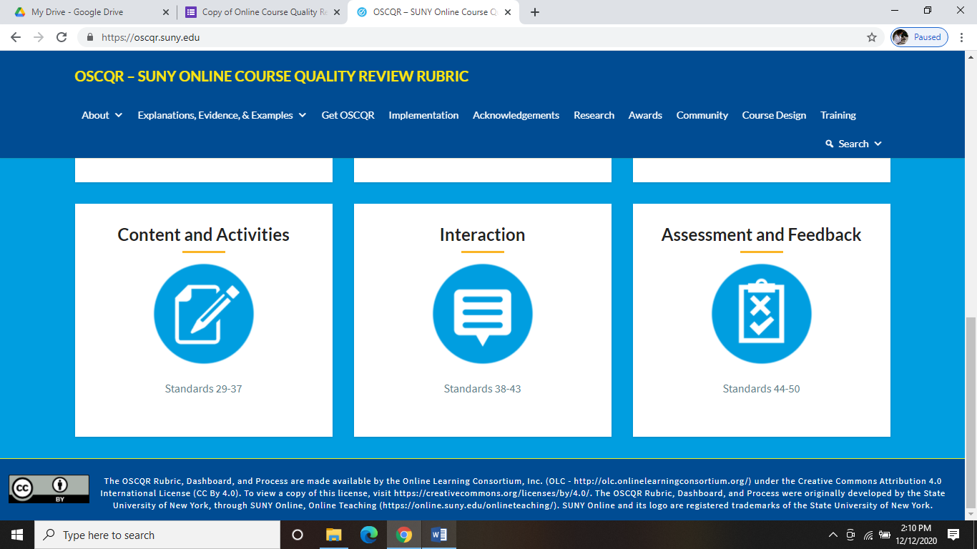**The interface of OSCQR (can be viewed at** [**https://oscqr.suny.edu/**](https://oscqr.suny.edu/) **)**

